**Overview of Transcription; *E. coli* RNA Polymerases**

* Know the general features of transcription
  + Transcription: the process of formation of RNA on a DNA template
    - RNA sequence is different from DNA – T is replaced with U
  + General Features of RNA synthesis
    - RNA is initially synthesized using a DNA template in the process called transcription; the enzyme that catalyzes the process is DNA-dependent RNA polymerase
    - All four ribonucleotides triphosphates are required, as is Mg 2+
    - A primer is not need in RNA synthesis, but a DNA template is required
    - As in the case with DNA biosynthesis, the RNA chain grows from the 5’ to the 3’ end. The nucleotide at the 5’ end of the chain retains its triphosphate group.
    - The enzyme uses one strand of the DNA as the template for RNA synthesis. The base sequence of the DNA contains signals for initiation and termination of RNA synthesis. The enzyme binds to the template strand and moves along it in the 3’ to 5’ direction
    - The template is unchanged.
  + RNA polymerase: enzyme that catalyzes the production of RNA on a DNA template
    - The five different types of subunits are: β, β’, α, σ, ω
    - Core enzyme (of RNA polymerase); the enzyme lacking the sigma subunit
    - Holoenzyme: an enzyme that has all component parts, including coenzymes and all subunits
    - The σ subunit recognizes the specific promotoers, whereas the β-, β’-, α-, and ω- subunits combine to make the active site for polymerization.
  + The promoter is the DNA sequence that signals the start of RNA transcription
  + RNA polymerase reads the strand from 3’ to 5’.

***E. coli* Promoters**

* Know the common features of *E. coli* promoters
  + Promoters are DNA sequences that provide direction for RNA polymerase
    - Closer to the 3’ end of the template strand or to the 5’ end of the coding strand
    - Binding site is said to lie upstream of the start of transcription
  + -10 region (TATA or Pribnow box)
    - Pribnow box: a DNA base sequence that is part of a prokaryotic promoter; it is located 10 bases before the transcription start site
  + -35 region: a portion of DNA that is 35 base pairs upstream from the start of RNA transcription that is important in control of RNA synthesis in bacteria
    - Core promoter: area from the -35 element to the TSS 🡪 UP element, which enhances the binding of RNA polymerase 🡪 extended promoter, region from the end of the UP element to the transcription start site
  + TSS (transcription start site): the location on the template DNA strand where the first ribonucleotide is used to initiate RNA synthesis
  + Promoter regions are A-T rich
    - Consensus sequences: DNA sequences to which RNA polymerase binds; they are identical in many organisms
    - The promoter base sequence controls the frequency with which the gene is transcribed

**Steps of Prokaryotic Transcription**

* Chain initiation
  + First phase: chain initiation: the part of transcription where RNA polymerase binds to DNA, the strands are separated, and the first nucleotide binds to its complement
    - Begins when RNA polymerase binds to the promoter and form the closed complex
      * Closed complex: the complex that initially forms between RNA polymerase and DNA before transcription begins
      * Open complex: the form of the complex of RNA polymerase and DNA that occurs during transcription
    - σ subunit directs the polymerase to bridge the -10 and -35 regions to the RNA polymerase
  + a purine ribonucleoside triphosphate is the first base in RNA
  + Just a few nt added before  subunit released
* Chain elongation
  + A transcription bubble of 17 base pairs moves down the DNA sequence to be transcribed.
    - RNA polymerase catalyzes the formation of the phosphodiester bonds
  + Transcription process supercoils DNA, with (-) supercoiling upstream and (+) supercoiling downstream
  + Role of topoisomerase: relaxes the supercoils in front of and behind the advancing transcription bubble
  + How RNA polymerase launches itself from promoter
    - Abortive transcription: RNA polymerase releases most chains near the beginning of the process
      * Cause: failure fo RNA polymerase to break its own bonds to the promoter
    - In order for chain elongation to occur, the RNA polymerase must be able to launch itself off the promoter
      * RNA polymerase is bound tightly to the DNA promoter and scrunches the DNA into itself, causing torsional strain of the separated DNA strands
      * Like a bow in a bowstring 🡪 provides energy to allow the polymerase to break free
* Chain termination
  + Involes specific sequences downstream of the actual gene for the RNA to be transcribed
  + Intrinsic termination: type of transcription termination that is not dependent on the rho protein
    - Controlled by termination sites—two inverted repeats spaced by a few other bases
    - Hairpin loop followed by string of U residues
  + 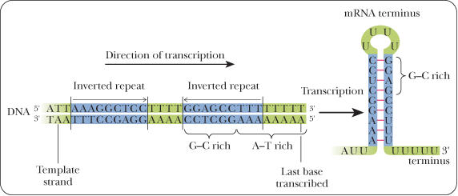
  + Rho termination
    - Hairpin loop causes RNA polymerase to pause
    - Rho protein catches up to polymerase and forces dissociation
  + 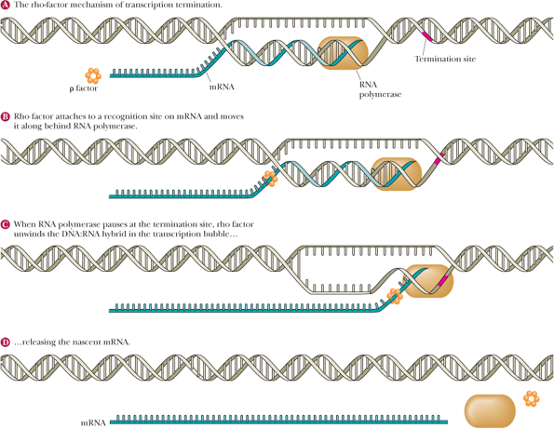

**Regulation of Transcription: Sigma Factors and Enhancers**

* In prokaryotes, transcription is controlled in four principal ways – alternative σ factors, enhancers, operons, and transcription attenuation
* Know that there are multiple sigma factors
  + Alternative σ factors: viruses and bacteria can exert some control over which genes are expressed by producing different σ-subunits that direct the RNA polymerase to different genes
  + 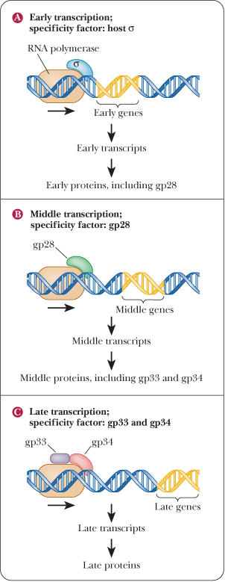
  + Know the significance of this in term of normal cellular function
  + Know the significance of this in terms of viral infection
* Know what enhancers are where they’re usually located
  + Fis sites: three upstream sites for rRNA production
    - Enhancers: DNA sequences that bind to a transcription factor and increase the rate of transcription
  + Recognized by transcription factors ( proteins or other complexes that bind to DNA sequences and alter the basal level of transcription)
  + Increases the level of transcription 🡪 enhancer
  + Decreases the level of transcription 🡪 silencer

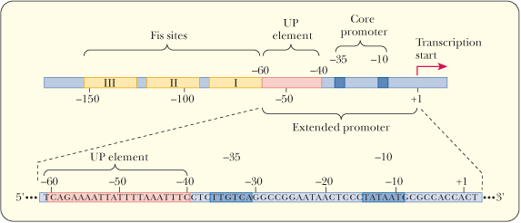

***Lac* Operon**

* Know the general principles of operons
  + Operon: group of operator, promoter, and structural genes
    - Group of prokaryotic genes that are coordinately regulated
  + The production of these proteins can be triggered by the presence of a suitable substance called an inducer -- induction
    - Regulated by induction
* Know the lac operon
  + Know the 3 structural genes
    - Structural gene: a gene that directs the synthesis of a protein under the control of some regulatory gene
      * lacZ: encodes β-galactosidase
      * lacY: encodes the enzyme lactose permease, which allows lactose to enter the cell
      * lac A: encodes an enzyme called transacetylase
    - expression of these structural genes is under control of a regulatory gene (lacI)
      * the regulatory gene is responsible for the production of a protein, the repressor.
        + Repressor inhibits the expression of the structural genes
      * In the presence of the inducer, this inhibition is removed.
  + Example of a negative regulation – lac operon is turned on unless something is present to turn it off, which is the repressor
  + Know the control sites
    - Promoter
    - Operator region (where repressor binds)
  + 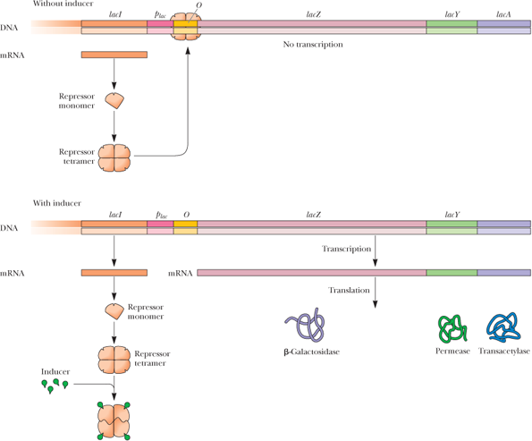

**Regulation of *Lac* Operon**

* Know how repression works
  + The repressor binds to the operator 🡪 RNA polymerase cannot bind to the adjacent promoter region, which facilitates the expression of the structural genes
  + Forms a tetramer when it is translated
* Know how the operon is induced
  + The inducer binds to the repressor 🡪 causing the repressor to be inactive 🡪 cannot bind to the operator 🡪 RNA polymerase can now bind to the promoter 🡪 transcription and translation can take place
  + Lac operon is induces when E. Coli has lactose and no glucose available
    - When both glucose and lactose are present, the cell does not make the lac proteins
    - Catabolite repression: the repression of the synthesis of the lac proteins by glucose
* Understand the principles of positive regulation
  + Positive regulation: modulation of transcription by CAP
    - CAP site: enhancer element
    - CAP-cAMP: transcription factor
  + protein (CAP): a protein that can bind to a promoter when complexed with cAMP, allowing RNA polymerase to bind to its entry site on the same promoter.
    - * When glucose is not present, cAMP is formed 🡪 hunger signal
* Trp Operon
  + Codes for five polypeptides, trpE through trpA
    - Catalyze the multistep process that converts chorismite to tryptophan
  + When tryptophan is plentiful, this repressor-tryptophan complex binds to the trp operator that is next to the trp promoter 🡪 prevents the binding of RNA polymerase 🡪 operon is not transcribed
  + When tryptophan levels are reduced 🡪 repression is lifted because repressor will not bind to the operator in the absence of the co-repressor, tryptophan
  + Negative regulation
  + Autoregulation – product of the trpR operon regulates its own production
  + 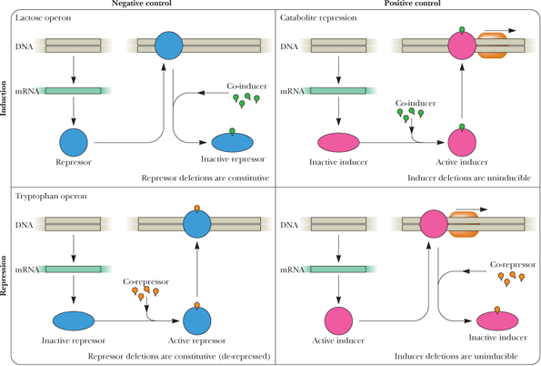
* 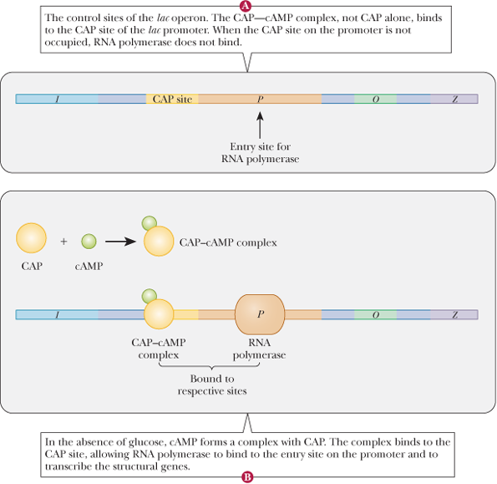

**Transcription Attenuation**

* Know the general principles of attenuation
  + Trp operon is regulated by transcription attenuation: a type of transcription control in which the transcription is controlled after is has begun via pausing and early release of incomplete RNA sequence
  + Series of mutually exclusive hairpin structures may form
  + Know the following and their significance:
    - 1-2 pause structure: a hairpin loop that can form during transcription attenuation, causing premature termination of transcription
    - 3-4 terminator: a hairpin loop that can form during transcription termination and that causes premature release of the RNA transcript
    - 2-3 antiterminator: a hairpin loop that can form during transcription attenuation, allowing transcription to continue.
    - 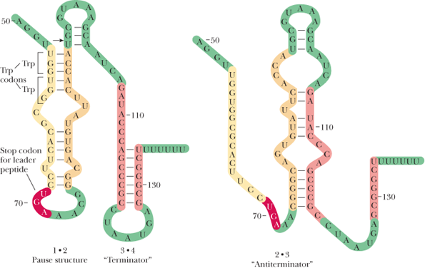
* Understand how attenuation works in the *trp* operon
  + Coupled transcription/translation essential to mechanism
    - Pause structure forms when the ribosome passes over the trp codons quickly when tryptophan levels are high. This causes premature abortion of the transcript as the terminator loop is allowed to form. When tryptophan is low, the ribosome stalls at the trp codons, allowing the antiterminator loop to form, and transcription continues
  + 1-2 pause loop forms and ribosome makes leader peptide
  + Know the consequences of high vs. low concentration of tryptophan
    - When the tryptophan is scarce, the operon is translated normally
    - When it is plentiful, transcription is terminated

**RNA Polymerase II Promoters**

* Know the roles of the three main RNA polymerases
  + RNA polymerase I is found in the nucleolus and synthesizes precursors of most, but not all, rRNAs
  + RNA polymerase II is found in the nucleoplasm and synthesizes mRNA precurosrs
  + RNA polymerase III is found in the nucleoplasm and synthesizes the tRNAs, precursors of 5S ribosomal RNA, and a variety of other small RNA molecules involved in mRNA processing and protein transport
    - All have two larger subunits
    - Overall different structure
* Know the features and roles of RNA Pol II promoters
  + Pol II have four elements
    - Upstream element: enhancers and silencers
      * Core promoter
        + GC box
        + CAAT box
    - TATA box: a promoter element found in eukaryotic transcription that is located 25 bases upstream of the transcription start site
  + 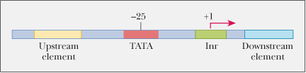
  + Initiator element: a loosely conserved sequence surrounding the transcription start site in eukaryotic DNA
  + Downstream regulator element: more rare than upstream regulators

**Steps in Eukaryotic Transcription**

* Biggest difference between transcription in prokaryotes and eukaryotes is the sheer number of proteins associated with the eukaryotic version of the process.
* Know that there are 6 general transcription factors
  + TFIIA, TFIIB, TFIID, TFIIE, TFIIF, and TFIIH
    - First bind to DNA to initiate transcription
* Understand the preinitiation complex
  + Transcription begins by the formation of preinitiation complex: in eukaryotic transcription, the phase wehre RNA polymerase and the general transcription factors bind to DNA
    - Where most of transcription control occurs
    - Where RNA polymerase and GTFs bind
* Initiation of transcription
  + TFIID binds to the TATA box. Then the other GTF bind. Kinases phosphorylate the C-terminal domain of Pol II 🡪 open complex in which the DNA strands are separated
* Transcription elongation
  + How controlled?
  + Requires elongation factors (EFs)
  + Know the roles of the following:
    - TFIIF: promoter targeting of Pol II
    - TFIIS:
    - P-TEF
    - N-TEF

**Regulation of Transcription: Mediator Complex and Nucleosomes**

* Know the role and mechanism of Mediator
  + Know how it works to silence a gene
* Know how the presence of nucleosomes affects transcription
* Know how nucleosomes modified to control transcription
  + Chromatin remodeling complexes
    - General way in which they work
  + Histone modifying enzymes
    - General way in which modified (methylation, acetylation, phosphorylation)
    - That this may turn transcription on or off
    - You do NOT have to know details of which residues are modified or how

**Regulation of Transcription: Response Elements**

* Know general principles of response elements
  + Enhancers that respond to metabolic factors
  + Regulate gene transcription under varied conditions
* Know the specific example of CREB and CBP
  + CREB binds to CRE enhancer – no transcription
  + Know the effect of raise in concentration of cAMP
    - How does this elevate transcription?

**Noncoding RNAs**

* Know the effects of ncRNAs and the two main types
  + miRNA
  + siRNA
* Understand how RNA interference works
  + Role of Dicer complex
  + Role of RISC
  + Role of Argonaut protein (Ago)

**DNA-binding Structural Motifs**

* Know the two domains of transcription factors
  + DNA-binding domain
  + Transcription-activation domain
* Know the DNA-binding domain features of:
  + HTH motif
  + Zinc fingers
  + Leucine zipper
* Know that the transcription-activation domain is where they bind other proteins
  + You do NOT need to know details

**Post-transcriptional Modifications of RNA**

* Know the general types of modifications
  + Trimming of sequences
  + Addition of sequences
  + Modification of bases
* Know the general modifications of
  + tRNA
  + rRNA
  + Eukaryotic mRNA
    - 5’ cap
    - PolyA tail
    - Why are these necessary for translation?

**Splicing of mRNA**

* Know how it is spliced
  + Introns removed and exons joined
* Know the splicing reaction
  + Where it takes place
  + Need for precision (why?)
  + Mediated by snRNPs
  + Know the steps of the splicing reaction
* Know the benefits of splicing
  + Alternative splicing gives rise to alternate RNAs and/or proteins

**Ribozymes**

* Know the significance of ribozymes
  + Catalytic RNA
* Know the difference between Group I and Group II

*Review Exercises Recommended:*

*1-8, 10, 11, 13-15, 17, 23-27, 30-34, 36, 38-41, 43, 46, 47, 49, 51, 54, 60, 62, 63, 65, 67-70, 73*